AI BASED MULTI-FORMAT QUESTION ANSWERING SYSTEM
A PROJECT REPORT
Submitted by
VENKATTALAKSHMI S
VIVEGAA J
THISANTHAN M S
SRIHARAN R
in partial fulfillment for the award of the degree
of
BACHELOR OF ENGINEERING
IN
COMPUTER SCIENCE AND ENGINEERING

SONA COLLEGE OF TECHNOLOGY,SALEM
ANNA UNIVERSITY ::CHENNAI 600 025
APRIL 2026

ANNA UNIVERSITY : CHENNAI 600 025
BONAFIDE CERTIFICATE

Certified that this project report “AI BASED MULTI_FORMAT QUESTION ANSWERING SYSTEM ” is the bonafide work of “ VENKATTALAKSHMI S, VIVEGAA J, THISANTHAN M S, SRIHARAN R” who carried out the project work under my supervision.

SIGNATURE SIGNATURE

HEAD OF THE DEPARTMENT SUPERVISOR

CHAPTER 1 – INTRODUCTION
1.1 Overview
The volume of digital information grows quickly in the last few years in different academic and business sectors and legal and technical fields. The essential knowledge of organizations is stored in different forms of documents such as PDF and DOCX and TXT and spreadsheets and code repositories and ZIP files that are compressed. The essential information is stored in these forms of documents. The user needs to carry out complex searches to extract different answers from these forms of documents. The search tools based on keywords cannot find the documents if different words are used to convey the same meaning. The problem increases for the system when it needs to process large unstructured documents or scanned documents. The problem is addressed by the project named ZIP-RAG based on the Retrieval-Augmented Generation method that provides answers based on semantics from the local document databases. The method is based on FastAPI and React 19 and LangChain and FAISS and Ollama for uploading different forms of documents for chat-based interaction without data transmission from the cloud.
The document intelligence system developed in the project is known as ZIP-RAG, and it has privacy as the major aim of its operation. The system allows users to access information while creating new answers through a mechanism that does not reveal any confidential information. The project has allowed the development of a full processing system that does not depend on external APIs since it operates through machines that are locally operated by users. The system has provided organizations with a major benefit since it has allowed them to maintain privacy by accessing information without the need for internet connection, and their expenditure remains controlled. The system has to allow for the operation of two major functions, which are presented in the project overview and viva materials. They are the basic document searching function and the advanced processing of large local document collections through structured data extraction.

1.2 Problem Statement

The main problem being addressed by ZIP-RAG is the difficulty in obtaining relevant information from large amounts of unstructured documents using current search tools. The current systems being used do not effectively serve users who want to obtain answers based on the meaning of the data, not the exact words. The main reason the system is facing challenges is because the users are uploading scanned documents. They are facing challenges with complex directory structures, which contain different file formats and ZIP files with many documents. They are using different systems, and the users want to access cloud-based LLM services and search tools. This is making the situation worse because it is costing them money and requires them to be online, which is risky to their data. They are losing control of their important documents. These current systems are not appropriate for working with academic documents, which require confidentiality. The project files uploaded to the system clearly show the limitations being addressed by the proposed system.
The current systems of question-answering based on a given document have some challenges due to the quality of results obtained from their retrieval system. The system is limited in retrieving information because it is using a single term to search for information in a system while ignoring other terms that may convey similar ideas. The system gives information that is either incomplete or incorrect due to these challenges. The absence of OCR technology in these systems means that when a user scans a document, he/she will get a blank page when scanning a document that has only image-based pages. These systems cannot support a ZIP repository as a single knowledge base because they are in different stages of projects, research, and records. The system has addressed some of its weaknesses by using a single local process based on semantic search, query expansion, and rank fusion, as well as OCR technology. The project aims at developing a system that can answer a question and support the answer with suitable documents using a system that will always give consistent results.

1.3 Objective of the Project

The objective of the project team, who are working in ZIP-RAG, is to develop an artificial intelligence-based question-answering system that can work offline without internet connection and provide privacy for the users through the processing of the documents. It is possible for the project to allow the users to upload the documents or ZIP files, which can then be processed by the system to extract the data from the uploaded files. Then, the system can provide the users with searchable data segments to assist in the natural language-based answering of questions. It is possible for the system to perform all the data processing operations within its own network environment without sending any data to other networks. It is possible to achieve the proposed project by developing a protected system, which can then be used to work on confidential information in a secure environment without the internet. It is possible for the uploaded materials to highlight the 100% offline performance as one of the objectives of the project.
This system is needed to fulfill two major objectives, which include the development of advanced techniques in the field of retrieval to enhance the precision of the answers. The ZIP-RAG system relies on the expansion of a number of queries to ensure the creation of different versions of the queries made by the user, which can be combined to ensure the achievement of the best results through the application of reciprocal rank fusion. The system can perform recall operations effectively, considering that it can protect itself from failing to perform the extraction of important information during the operation. The system is needed to perform deep extraction from scanned documents through the application of OCR, and it should be able to perform the extraction from PDF, DOCX, XLSX, CSV, text, and code files, which should be parsed. The system should be able to display a new interface created by React to the user, displaying a tree of files and converting them to markdown.

1.4 Scope of the Project
The entire question and answering document process, right from the submission of files to the delivery of the answers, is included in the scope of the project. The backend of the project requires the developers to follow these steps for document processing: document ingestion and zip extraction and file type detection and text parsing and OCR and text chunking and embedding generation and FAISS indexing and query expansion and retrieval fusion and Ollama-based local language model inference. The requirements for the project in the context of the development of the frontend include the following: file upload, document tree visualization, chat system, answer display, source retrieval visual, and many more. The project can be controlled in the form of a client-server application, which means it can be controlled by React for the user interface and FastAPI for the AI processing system. It is related to the architecture, which means it is related to the architecture discussed in the overview document and the viva document.
It also includes functional deployment services that make the execution of the system possible. The presentation slides that the user uploads also include start-up scripts that can be executed with the click of a button in the Windows environment to run the system with the least technical knowledge required. The project is far beyond the scope of what is required for a simple prototype to deliver a fully functional academic system for the purpose of production. The system is well-suited for enterprise knowledge bases, software project repositories, academic PDF document sets, legal document reviews, and many other purposes where reliable question answering is required through personal local access. The project is for local offline intelligence as it does not include features such as cloud authentication, training from scratch, or API dependence.

CHAPTER 2 – LITERATURE SURVEY
2.1 Research Work
The growth of Artificial Intelligence has seen tremendous growth, leading to an improvement in the development of Natural Language Processing Systems that can comprehend human communication more effectively. The invention of Large Language Models has been a breakthrough in Artificial Intelligence, allowing the creation of human-readable texts through understanding the context of information. The independent working of LLMs has resulted in two challenges: LLMs producing false information and LLMs not being able to possess knowledge, access confidential information, or access information in a timely manner. There are various issues with the system, and they have been addressed through Retrieval-Augmented Generation.
The RAG system has been developed by Lewis and his team in 2020 by designing a system that has a retriever to retrieve information from a knowledge base and a generator to generate answers based on information retrieved from documents. The system is more accurate in generating factual information compared to information generated by the generator itself. The retriever in the system uses dense vector text representation, allowing semantic search to be performed on the documents instead of keyword search. The basic principle on which all the document-based question-answering systems function can be understood by understanding the ZIP-RAG system, which is being implemented in this project.

The research carried out by Cheng and his team in 2025 is a survey on the knowledge-based RAG system. The team has shown how these RAG systems can function in a real-world business scenario in terms of enterprise search systems and customer support systems. The survey has shown how these RAG systems can function in a more efficient manner by integrating these systems with the semantic retrieval system and the indexing system. Most of these RAG systems have to function on a cloud environment with high-end GPUs and cannot function in environments where privacy protection
The RAG system was created by Lewis and his team in 2020, when they developed a system that utilized a retriever to retrieve documents that contain relevant information and a generator to create an answer based on the documents retrieved. The system generates more accurate results compared to what a standalone generative model generates on its own. The retriever works on dense vector text representations, allowing semantic matching to occur as opposed to matching on specific keywords. The underlying principle that governs all current document-based question-answering systems becomes apparent when looking at the ZIP-RAG system, as demonstrated in this project.

Another significant contribution is the QASPER dataset proposed by Dasigi et al. in 2021. Once again, the focus is on the question-answering task for scientific documents. The significance of deep reasoning for complex texts is emphasized by this contribution. The limitations of the use of keyword-based search methods are also emphasized. Again, these search methods are for the data sets considered for this contribution. The methods cannot be generalized for data sets such as spreadsheets, code files, and ZIP archives.
The research carried out by Karpukhin et al. in 2020 on Dense Passage Retrieval further affirms the concept of semantic search. In this research, a new paradigm has been introduced in the use of neural embeddings. This new paradigm can be employed in the efficient retrieval of passages depending on the queries. The paradigm has been widely used in the current RAG models. It can also be employed in the ZIP-RAG project, where neural embeddings are computed locally and then stored in a FAISS database.

Furthermore, other research has been carried out, such as the LayoutLM model by Xu et al. in 2020. This research has mainly focused on improving the understanding of documents depending on the use of text and layout information. The model can efficiently handle different types of documents such as invoices. However, this model cannot be employed in practice because it requires large amounts of data, which is not in conformity with the ZIP-RAG idea of converting any type of document into plain text for efficient handling.
The latest developments in the field of multi-agent RAG systems, such as SQuAI 2025, show how multiple agents in a system work in coordination with each other to improve the quality of answers provided by a system. Even though these developments improve the quality of reasoning, they are complex and increase computation time, which may not be suitable for an academic project with a local deployment goal. ZIP-RAG solves this problem through the use of multi-query expansion and rank fusion, which are less complex.

The second area of research in this project is document question answering with multiple formats of data. The current state-of-the-art systems are designed to work with a single or multiple file formats, such as PDF and text files. In most real-world scenarios, data will be available in multiple formats, such as word files, spreadsheet files, and zip archives. The research paper provided in this project emphasizes the importance of using multiple parsers and preprocessing techniques in building a robust system. ZIP-RAG takes this concept a step further by supporting multiple file formats and recursive parsing of zip archives, making it more robust than other traditional systems.
Additionally, the concept of privacy-preserving AI has gained significant importance in recent research studies. The existing AI-based solutions are implemented using a cloud platform, which poses a security threat. Recent research studies have identified the necessity of implementing offline-based artificial intelligence solutions. ZIP-RAG specifically focuses on this requirement, where computations are performed locally, such as embedding, vector search, and language model inference.

Summary of Literature Survey

From the literature survey, it is identified that Retrieval-Augmented Generation has a significant role in improving the accuracy of question-answering systems in comparison with other available solutions such as LLMs. Additionally, semantic search using vector embeddings has proved its efficiency in comparison with other available solutions such as keyword-based searching, especially for large-scale complex data sets. However, most of the available solutions are found to have some level of limitation in terms of a cloud-based environment requirement.
Moreover, there is a possibility that the existing document QA systems might not support different file formats and might not efficiently handle ZIP repositories. It has to be considered that there might be a need for high computational power in some of these advanced models, which might not be available in existing systems. There is a need to have offline AI systems to provide efficient and secure document analysis.

The proposed ZIP-RAG system can efficiently provide offline LLM, document processing in different formats, and efficient document retrieval. It can provide a practical solution for private document QA by integrating all these features in one system.
CHAPTER 3 – SYSTEM ANALYSIS
3.1 EXISTING SYSTEM
In the existing digital system, different techniques are being used to extract the information from the document and to answer the query posed by the user. It is done using different techniques like the keyword-based search engine or the cloud-based artificial intelligence system. These techniques are developed to extract the information from the document based on the keyword or the indexing method. But these techniques are not efficient in providing the context-based answer to the query posed by the user using the large number of documents.
In the existing document-based question answering systems, the majority of the systems are developed using the cloud-based Large Language Model (LLM) system. It provides the platform to the user to upload the document and pose the query in the natural language. But the system is facing many limitations, such as internet connectivity, which affects the usage of the digital system.
The next limitation of the current systems is that they can only handle a single type of file. For example, they can handle a PDF document or a text document, but they cannot handle complex document structures such as a spreadsheet, a programming document, or a ZIP file with multiple documents. In a real-world scenario, in a software development environment, the data will be in a compressed folder, which cannot be handled by the current systems as a single knowledge base.

Another limitation is the fact that the current systems can only support single query-based information retrieval systems. This means that in case the user wants to query the current systems, the user will only be able to access the information which is relevant to his/her query on the basis of single query representation. This will result in the lack of information because the current systems will not be able to access the information which is semantically related to the query of the user. This will result in the generation of wrong answers.
The project files show that the current solutions lack the integration of multi-format parsing, semantic retrieval, and offline processing. The current systems lack the ability to work efficiently on local machines without the presence of any dependency.
3.1.1 Disadvantages
The disadvantages of the existing system are as follows:
Privacy Risk:
The existing system has to upload the documents to a cloud platform, which can cause a risk of data leakage to third parties.
Internet Dependency:
The existing system cannot function without internet access, which is a major drawback because these systems cannot function in a network environment.
Limited Format:
The existing system can only handle a limited number of file formats, and the ZIP format is not supported.
High Operation Cost:
The existing system, which functions on APIs, has a high operation cost because they charge on the basis of usage.
Lack of OCR:
The existing system does not support scanned documents, which is a major drawback.
Poor Retrieval Accuracy:
The existing system, which functions on a single query, does not provide accurate results because it cannot read semantic queries.
Delayed Response Systems:
The existing system takes a very long time to respond because they take a very long time to process queries.
Lack of Integration:
The existing system, which functions on a combination of tools, lacks integration.
The disadvantages of the system have shown that there is a need for a more efficient system.
3.2 Proposed System
3.2.1 Overview
The proposed system is called ZIP-RAG. It is a completely offline document question answering system, which is capable of supporting different document formats. It is called the Retrieval-Augmented Generation model. It is designed to overcome the limitations of the current question answering systems. It provides a single platform to perform document ingestion, processing, indexing, searching, and answering.
In the proposed system, the architecture is client-server-based. It utilizes React 19 for the front end and FastAPI for the back end. It performs all the operations on the back end. It utilizes the FAISS library as the local vector database. It is used to store the vector embeddings and search them. It utilizes the local LLM to perform the answering. It utilizes Ollama to perform the answering. It means the data is not sent to the server. It can support different document formats. It supports PDF, DOCX, XLSX, CSV, TXT, and code files. It supports ZIP files. ZIP files will be recursively extracted. It utilizes the OCR tool to support scanned documents. It means no matter what the document is, it can be extracted and searched.
The other significant feature is the utilization of complex search techniques such as Multi Query Expansion and Reciprocal Rank Fusion. These techniques are significant in improving the accuracy of the results obtained from searching, as they generate different semantic variations of a query asked by a user and then fuse them in order to obtain the required information.
The other significant feature is the utilization of a new interface with the capability to stream results in real time.
3.2.2 Modules and Their Functionalities
The ZIP-RAG architecture consists of various modules, with each module carrying out a certain functionality. The modules include:
1. Ingestion Module:
This module is used to ingest the files that the user wants to upload. The module can handle the uploading of both single files and ZIP archives. In the case where ZIP archives are used, the module is capable of recursive extraction.
2. Parser Module:
This module is used to determine the type of the files. Various parsing techniques are used in the process. Various libraries are used to parse the different types of files such as PDF, word documents, spreadsheets, and many more. The module also uses Optical Character Recognition to parse scanned documents.
3. Chunking Module:
Documents are divided into smaller units referred to as chunks. This is used to enhance efficiency and ensure the effective functioning of the retrieval system.

4. Embedding and Indexing Module:
Each document is converted to a vector through the use of the transformer-based embedding model.
5. Query Expansion Module:
Once the user has provided the query, this module expands the query semantically to enhance its result coverage.
6. Retrieval and Fusion Module:
This module retrieves pieces of relevant documents from the expanded queries using Reciprocal Rank Fusion.
7. Generation Module:
The final step involves sending the context to a local LLM, which generates a response, and this response is sent back to the user interface in real-time.
The modules work in a pipeline to efficiently execute this task of document-based question answering.
3.2.3 Advantages
The proposed system in this paper also has some advantages over other existing systems. The advantages of the proposed system are:
Ensure data privacy is maintained in a complete offline mode
Supports multiple file formats and also includes the facility for handling ZIP archives
Facilitates the handling of scanned data by implementing OCR
Improves the accuracy of data retrieval by implementing new techniques
There are no recurring costs involved in the proposed system, as APIs are not required
Facilitates real-time responses by implementing the streaming facility
Has a user-friendly and interactive interface
Efficiently works on normal hardware
3.3 System Requirements
3.3.1 Hardware Requirements
The system can run on any general computer device. The hardware requirements for the system are:
Processor: The system requires a multi-core processor. The required processor is Intel i5.
RAM: The system requires a minimum of 8 GB RAM, though 16 GB is recommended.
Storage: The system requires a Solid State Drive to store the indexing of the documents.
3.3.2 Software Requirements
The software required for the system is:
Operating System: The system requires an operating system such as Windows, Linux, or macOS.
Backend: The system requires Python 3.10+, FastAPI, Uvicorn.
AI Framework: The system requires LangChain, HuggingFace Transformers.
Vector Database: The system requires FAISS.
Parsing Library: The system requires PyMuPDF, Docx2txt, OpenPyXL, RapidOCR.
Frontend: The system requires React 19, Tailwind CSS, Axios.
LLM Runtime: The system requires Ollama.
The software required for the system should be installed in the latest version. All the software required for the system will work.

3.3.3 Software Description
The backend of the system is developed using FastAPI. FastAPI is used for the efficient handling of API requests. ASGI server is used to develop the server. LangChain is used for the orchestration of the entire system.
FAISS is used to develop the vector database. Embedding model is used to transform the text into vectors. Vectors can be stored efficiently using the vector database.
The frontend of the system is developed using React 19. React is used to develop the frontend. It is a high-performance framework. It is used to develop the responsive interface. The usage of React is to develop the responsive interface.
Ollama is used to develop the Large Language Model. Large Language Model is run using Ollama. It is run locally without the usage of the internet. LLaMA 3 and Mistral are run locally without the usage of the internet.
Software architecture is developed to be modular, efficient, and scalable. It is developed to be used in the real world as well as in the research field.

CHAPTER 4 – DESIGN AND IMPLEMENTATION
4.1 Methodologies
The design and implementation of the ZIP-RAG have been carried out through a pipeline-based methodology in which each stage of the system is responsible for performing a single task before passing on the task to the next stage of the system. Such a methodology is most suited for the implementation of a Retrieval Augmented Generation system because each of the operations involved in the ingestion of the documents, such as the extraction of the contents of the ZIP archives, chunking of the extracted data, indexing of the data, generation of the answers, etc., requires different strategies. The implementation of the system has been carried out in such a way that it can function completely offline by making use of tools such as FastAPI, React 19, LangChain, FAISS, Ollama, etc., as indicated by the project materials uploaded for carrying out the viva. The methodology for the implementation of the ZIP-RAG has been carried out in such a way that the ingestion of the data, extraction of the data from the archives, chunking of the data, generation of answers, etc., have been carried out.

4.1.1 Training
The ZIP-RAG system does not use a traditional machine learning approach where a model is learned from scratch. This is due to the fact that the ZIP-RAG system utilizes a number of pretrained models for its embedding and local language generation capabilities. The embedding model, which is a variant of the All-MiniLM-L6-v2 model, is utilized for transforming a chunk of text into a numerical form. On the other hand, the Ollama utilizes a local LLM such as Llama 3 or Mistral for its local language generation capabilities.

The training stage of the project could be considered a stage of preparation where a document corpus is modified and adapted, although not in a traditional approach to learning a machine learning model, which is a process that has already been undertaken for a number of pretrained models for embedding and local LLM capabilities. This makes the system efficient since a costly training process has already been undertaken for a number of pretrained models.
4.1.2 Feature Mapping
As far as feature mapping in the context of ZIP-RAG is concerned, it can be defined as follows: “feature mapping is the way in which data is mapped onto a vector space such that similar data is clustered. In other words, the textual data chunks are mapped onto a vector space by applying the local sentence transformer model. The vectors thus represent the actual meaning of the data. The actual meaning of the data is significant in the context of semantic question answering. According to the project files, these vectors are then stored by applying the FAISS library for similarity search.”

The feature mapping is significant in the context of connecting human language with machine search. For example, in the context of searching for “project objective,” the data can be mapped to different chunks of data by using different words such as “goal,” “aim,” “purpose,” as long as the meaning of the data is similar. Thus, feature mapping can be useful in improving the search query. Moreover, the application of the dense passage retrieval concept can also be noted.
4.1.3 Visualization and Interaction
The ZIP-RAG is not only meant to act as a backend system for information retrieval purposes but is also meant to act as an interactive system. The front end of the ZIP-RAG is built using React 19, which is a very modern front-end technology. The front end is also provided with a chat window, a drag-drop file uploader, and visualization of the file tree for the ZIP archives and the documents inside the ZIP archives. Therefore, the front end of the system is also meant to act as a visualization tool for the Markdown and the mathematical notation, which is very vital for the understanding of the answers provided by the system.

The use of visualization in the project is very vital because it will help the user understand what the system is doing with the information provided. The use of visualization in the project is very vital because the project is meant to act as a document intelligence system. The interaction of the user with the system is very vital because it will help the user gain confidence, especially when working with multiple documents.
4.1.4 AI-Guided Feedback

The quality of the response is enhanced by the use of AI-guided feedback. In this case, the quality of the response is ensured to be generated on the basis of the relevant content retrieved. Once the content is retrieved, the intent-aware prompt is generated, and the context is sent to Ollama. The context sent to Ollama, as shown in the uploaded materials, indicates that the prompt can be varied on the basis of the action to be performed, such as debug, summarize, or explain. This indicates that the quality of the response can be varied on the basis of the intent of the user.

This enhances the quality of the response because there is no hallucination involved. The model is not required to generate a response on the basis of the information available in the memory. Instead, the model is required to generate a response on the basis of the context sent. If the intent of the user in the question is not clear, there is a higher probability of retrieving relevant content on the basis of semantic expansion and fusion. This is one of the advantages of the ZIP-RAG methodology.

4.1.5 Performance Evaluation
The system is tested on the basis of different parameters of its performance, which include its precision in data retrieval, quickness in terms of its response, its precision in results, its success in indexing data, and quickness in responding with results in the form of answers. As per the project overview provided in the problem statement, “The architecture is optimized for consumer-grade CPUs and GPUs; our vector store can index thousands of chunks on a standard laptop.” This indicates that, in this project, performance evaluation is not restricted to precision in results, but it is further extended to how easily the system can be deployed.

As per the result section in the viva materials provided, “We support indexing mixed-format ZIP archives, OCR on scanned PDF pages, and SSE response in token form.” This indicates that this system is not restricted to a theoretical approach, but it is further extended to a practical approach as well. Performance evaluation in this project is restricted to how well this system can be used as a whole, how well data can be retrieved, how well data privacy can be maintained, and how quickly results can be obtained in the form of answers.

4.1.5 Performance Evaluation
The system is being tested on various performance parameters, such as the precision of the system's retrieval, the responsiveness of the system, the accuracy of the system's OCR, the success of the system's indexing, and the quick delivery of the system's answer. The project overview section of the project report indicates that the system's architecture has been optimized for consumer-grade CPUs as well as GPUs, with the vector store being able to index thousands of chunks on a normal laptop.
Furthermore, the result section of the viva material indicates that the system is able to index mixed-format ZIP archives, perform OCR on scanned PDF pages, as well as answer the request token by token with SSE. This indicates that not only is the system effective in theory, but also in practice. The system's performance is being tested on various parameters, such as usability, accuracy, maintaining privacy, as well as speed.
4.2 Architecture Diagram

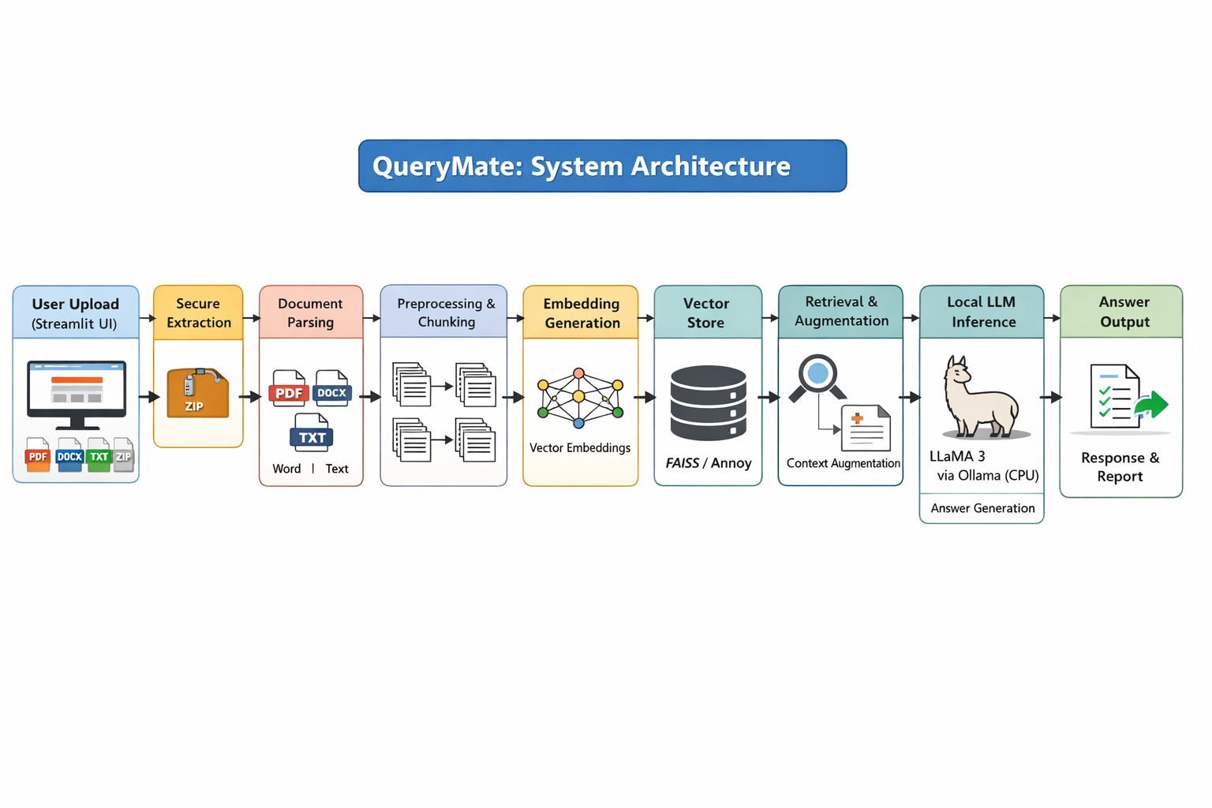
Figure 4.1: ZIP-RAG System Architecture
As can be seen from the above diagram, the architecture diagram for the ZIP-RAG system is shown in Figure 4.1 above. As can be noted from the above diagram, the system architecture is based on the client/server approach with different layers for user interaction, document processing, document retrieval, and document generation. It is important to note that the client layer is built on top of React 19, while the server layer is built on top of FastAPI and Uvicorn. In addition, the storage layer is built on top of FAISS, while the inference layer is built on top of Ollama. As noted earlier, the system architecture is such that the client is not frozen when the server is undergoing intense processing. As such, the system is not frozen when the server is busy with intense processing. In addition, the system is such that the output is streamed to the user through the use of Server-Sent Events. As such, the user is not forced to wait for the entire answer to be generated before the first token is generated.
4.3 Class Diagram
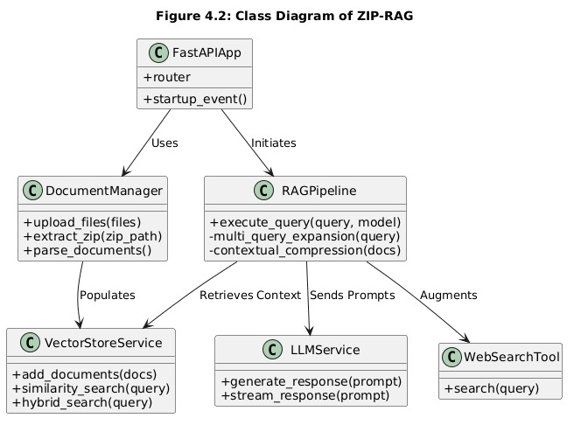
Figure 4.2: Class Diagram of ZIP-RAG
The class diagram of ZIP-RAG can be interpreted as the modular object-oriented view of the system’s pipeline. Even though the code is written in a function-based paradigm, the system can still be represented logically in terms of classes for documentation purposes. The major classes of the ZIP-RAG system are DocumentManager, ParserManager, Chunker, EmbeddingManager, VectorStoreManager, QueryExpander, Retriever, AnswerGenerator, and UIController.

DocumentManager receives the uploaded documents and checks whether the input is a single document or a zip archive. ParserManager routes the input file to a parser based on the extension and content type of the input file. Chunker divides the text into chunks in a manner that ensures important context is not lost. EmbeddingManager converts each chunk into a vector based on the given model, as described in the project overview above. VectorStoreManager stores and retrieves vectors based on the FAISS library. QueryExpander generates semantic alternatives of the question posed by the user, while Retriever performs a search and rank fusion. Finally, AnswerGenerator sends the context retrieved by the retriever to Ollama and then returns a response to the frontend.

This class design makes the system easier to maintain since each of these components is a single responsibility. It also makes it easier for another developer to add another type of file parser, retrieval strategy, or even the model backend without modifying the overall design of the system. The modularity of the design is in line with the design goals.

4.4 Use Case Diagram

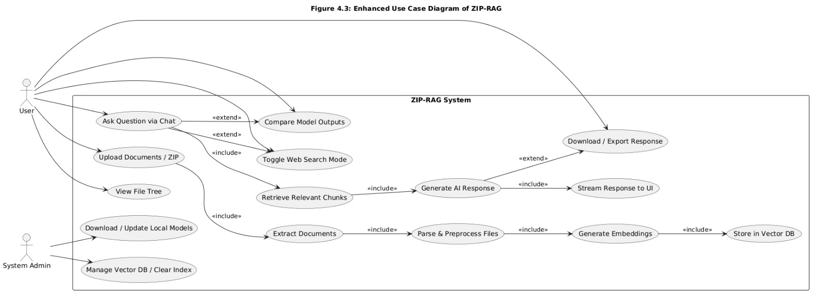

Figure 4.3: Use Case Diagram of ZIP-RAG

The key actor in ZIP-RAG is the user. The user has a number of roles to play, which include uploading files, viewing document structure, asking questions, and receiving answers according to the uploaded documents. At times, the user can replace the documents as well. At the same time, while interacting with the system, the system will respond by retrieving the documents, indexing them, and generating answers through this process.

Some of the key use cases in ZIP-RAG include uploading the document, extracting the ZIP archive, parsing the multi-format files, producing embeddings, storing vectors, querying the KB, retrieving relevant chunks, producing the response, and viewing the output with markdown rendering. Since this is an offline tool, there is no requirement to use any API/cloud in the entire process.

4.5 Sequence Diagram
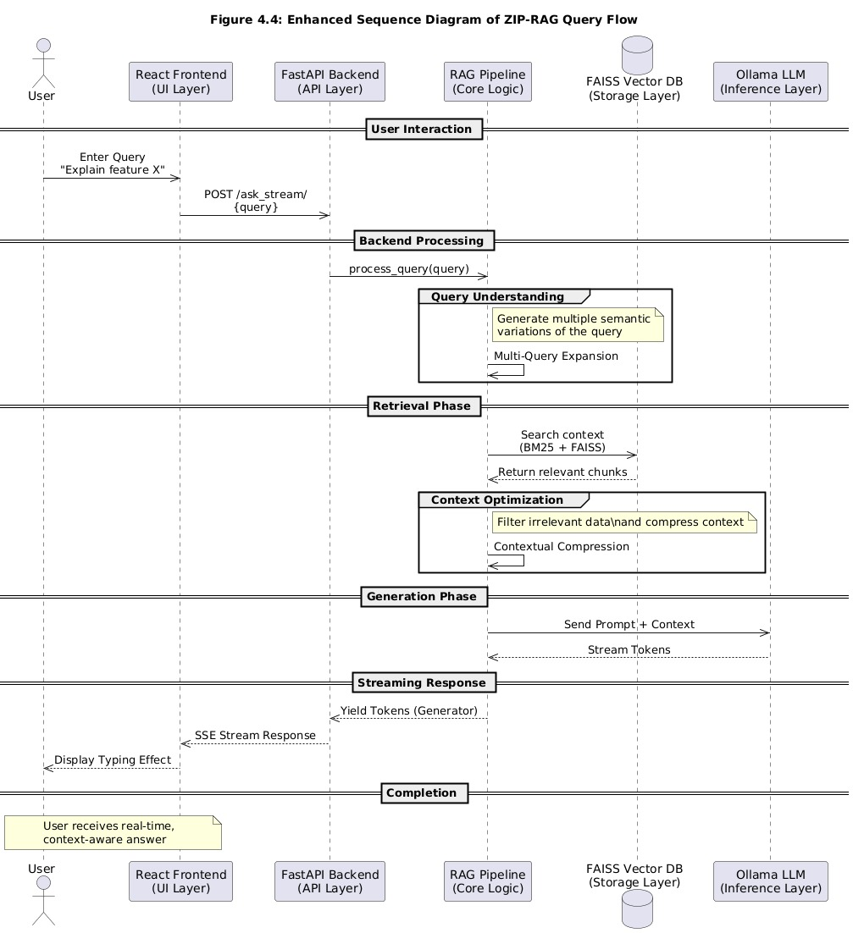

Figure 4.4: Sequence Diagram of ZIP-RAG Query Flow

As shown in the sequence diagram, the flow starts with user action, where the user will be prompted to upload a document or a ZIP file using the React frontend. This will be sent to the FastAPI backend for processing. During processing, the types of files will be identified. After that, text processing will be done using a parser, where text will be divided into chunks. After that, embedding will be done, followed by indexing using the FAISS algorithm.

The user will be prompted to input a query, which will be sent to the backend using the frontend. Query expansion will be done to create different semantic representations of a query. A single query will be sent to the FAISS algorithm.
These retrieved results are then combined by using the Reciprocal Rank Fusion method. After that, the best context is filtered or compressed. This filtered context is then sent to Ollama along with the intent-based prompt. The answer is then generated by using Ollama. This generated answer is then sent back to the user interface token by token by using SSE.

This series of steps is important as it depicts how exactly ZIP-RAG is able to strike the right balance in terms of accuracy and quickness in results. This is achieved in association with the help of semantic query variations. This is achieved in association with the help of the stream. It is important to note how exactly the answer is generated in association with the help of the document.
4.6 Feasibility Study
The project feasibility study is an assessment of a project to determine if it is possible to execute a project. It is an assessment of a project to determine if a project is technically, economically, and behaviorally feasible. ZIP-RAG project, in this case, is feasible because the project is using existing open-source tools and architecture, which can be executed on a local machine.

4.6.1 Technical Feasibility
From a technical point of view, the ZIP-RAG project is technically feasible because the project is using existing libraries and architecture for some of the components. FastAPI can be used to handle the asynchronous call to API, React can be used to handle the interface, FAISS can be used to handle vector search on a local machine, and Ollama can be used to handle the language model on a local machine. The libraries used in this project to handle document parsing, such as PyMuPDF, RapidOCR, Docx2txt, and OpenPyXL, can be used to handle documents, meaning that this project can be executed without a need to design infrastructure.
The project is also technically feasible based on the existence of the steps involved in the process. The steps involved in the project include document parsing, embedding, retrieving, and generating. The steps involved in the project are independent of each other. The project structure based on the files provided indicates that the project is already implemented and is able to run in real-time and offline.

4.6.2 Economic Feasibility
The project is also economically feasible based on the elimination of the costs involved in accessing cloud APIs. The fact that the project runs locally indicates that the user does not incur costs based on the number of tokens. The fact that the project utilizes open-source tools indicates that the project is economically viable. The project could be considered viable for an institution or an individual working with many document archives.
The other economic benefit is that it can be implemented on normal laptops/desktop systems, unlike cloud servers. This is significant in this case, as the cost will be less, especially since this project can be implemented in an academic environment.

The project is economically viable, as mentioned in the above points, since the project is software-centric with free components. This implies that the project has a high benefit while having a low cost.

4.6.3 Behavioral Feasibility
The behavioral feasibility aspect of a system focuses on how a system is viewed by a user as acceptable, comprehensible, and beneficial to them. ZIP-RAG is a system with high behavioral feasibility, as the user will be able to interact with the system through asking questions using a chat box, which is comprehensible to the user.
The system could also prove to be very useful in a research environment, a software development team, or a law firm where the user may not want to store information in a cloud-based system. This is due to the fact that they will be keeping the information in-house, which is in line with their perceptions of privacy. The ability to provide source-grounded responses could also prove to be helpful in establishing a level of trust, which is a behavioral factor to consider.

CHAPTER 5 – CONCLUSION AND FUTURE WORKS
5.1 Conclusion
The project of implementing a solution for a fully offline and private document-based question and answer solution by utilizing existing information retrieval and information generation technology is a success. The solution provided by the ZIP-RAG project is different from other traditional cloud-based information assistants in that it provides a facility for performing all operations on the user’s machine, which is a significant advantage. The project resources of the ZIP-RAG project prove that the solution is intended for addressing the problems of keyword search, internet dependency, format restrictions, and privacy. The project is also a success in that it utilizes existing information retrieval and information generation technology for implementing a solution for a fully offline and private document-based question and answer solution.
Another significant outcome of this project is the quality improvement in document chunk retrieval. This has been achieved through the application of Multi-Query Expansion and Reciprocal Rank Fusion. ZIP-RAG has the advantage of retrieving more relevant document chunks than other single query-based approaches. This has enabled the system to efficiently respond to queries posed by the end-user, despite the fact that the end-user may not have any direct matches to the text contained in the documents. The application of FAISS for local vector storage and Ollama for offline generation has enabled the system to become efficient, scalable, and cost-effective. Therefore, ZIP-RAG has demonstrated an efficient application of Retrieval-Augmented Generation, not only in the project but in the application as well.
The project has demonstrated the importance of interface design in AI systems. This has been achieved through the application of React 19, a frontend, a file tree, markdown, and token-by-token response streaming. The system has become efficient and transparent to the end-user. The end-user can visually see whether the files are processed correctly or not. The end-user can visually see whether the answers are correct or not, as they are generated from the documents. Thus, ZIP-RAG has been successful in achieving its objectives of offline generation, preserving user privacy, supporting multiple formats, and context-aware answering.

5.2 Future Works
The system of ZIP-RAG, which has been proposed, is quite robust in terms of document intelligence, and there are a number of avenues through which improvements can be made to this system. One of the avenues, through which improvements can be made to the proposed system, is through an improvement in the multimodal capabilities of this system, which would allow it to perform reasoning over the images, diagrams, tables, and charts included in a document. Although a system of OCR has been included in this system, which would allow it to perform better over scanned documents, a better vision-language model can be included, which would allow a better reasoning over technical papers and reports.

Another area, through which improvements can be made to this system, is through a better reranking of the documents, which have been retrieved. Although a system of a new reranker, namely "Multi-Query Expansion and Reciprocal Rank Fusion," has been included, which would allow a better relevance of the documents, a better reranker can be included, which would allow a better reranking of the documents, which would be applicable in the case of a number of chunks being semantically similar.
Another improvement that can be made to this system is with regard to multiple users, such that this system can be used in a lab, department, or enterprise setting.

Another aspect of future work that can be done on this system is related to the deployment of the system. For example, making this application a cross-platform desktop application, such as through the use of the Electron framework, can help make this system more accessible to non-technical users. Making this system do hybrid web searches can help answer questions where new information must be known. Improvements to citation highlights, confidence, and answers can also be made to help make this system more accessible. All these improvements can help make this system transition from a strong academic system to a more complete private AI document assistant.

